1. What do you mean by cells in an excel sheet?

Ans: CELLS: A cell is a rectangular area formed by the intersection of a column and row. Cells are the building blocks of the Excel Worksheet. Cells are identified by the Cell name (or Reference, which is found by combining the Column Letter and Row Number.) Cells may contain Labels, Numbers, Formulas, or Functions.

Ex: cell in column “C” and in Row “3” would be cell C3.

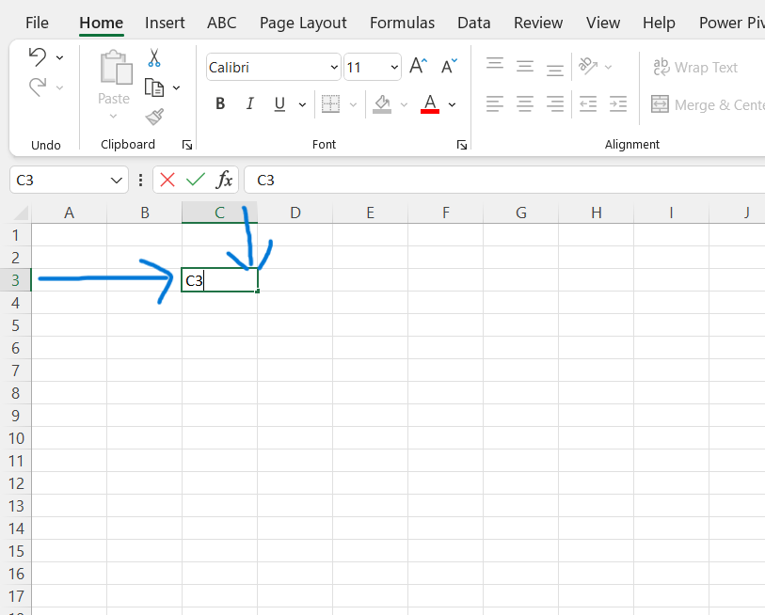

2. How can you restrict someone from copying a cell from your worksheet?

Ans : In order to protect the worksheet from getting copied , we need to go into MENU bar > REVIEW > PROTECT SHEET > PASSWORD. By entering password , you can secure your worksheet from getting copied by others.

By default , when you protect a worksheet , all the cells on the worksheet are locked , and users cannot make any changes to a locked cell.

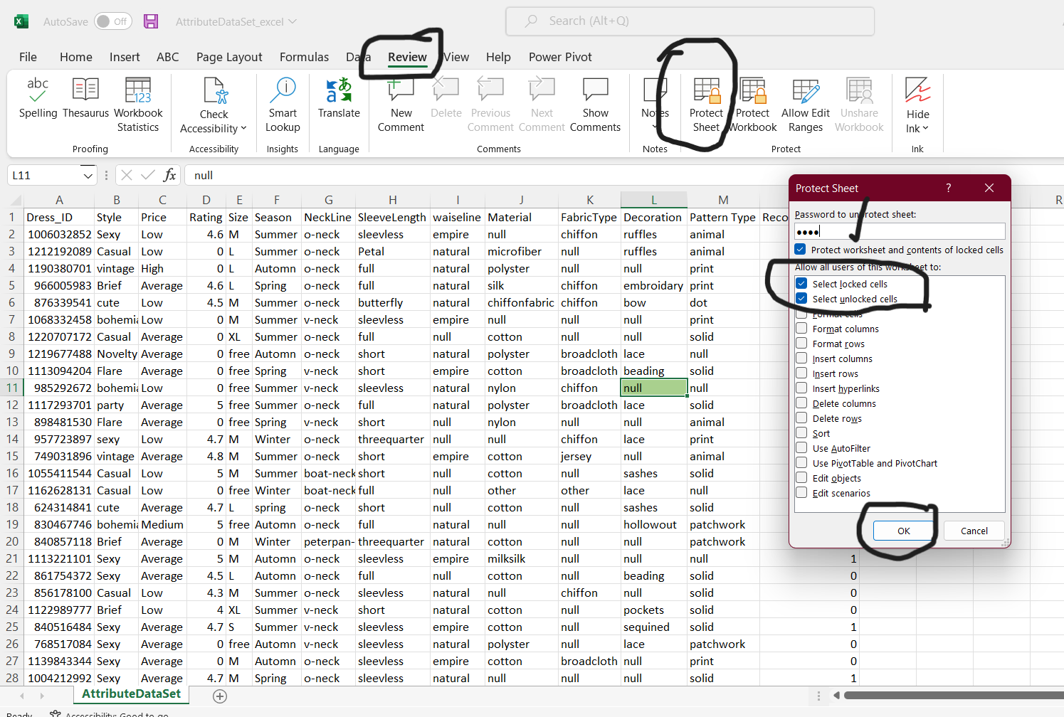

To set a password to protect cells, follow the following steps.

Step 1: go to REVIEW and click on “PROTECT SHEET” option.

Step 2: Excel opens the Protect sheet dialog box. By default, Excel selects the protect worksheet and contents of Locked Cells check box.

Step 3 : Select any of the check boxes in the Allow All Users of This Worksheet To list box. ( Such as Format Cells or insert columns ) that you still want to be functional when the worksheet protection is operational.

The selected Locked cells and select unlocked cells check boxes are selected by default.

Step 4 : Type the password in the “Password to unprotect sheet “ text box.

Step 5 : click OK

Step 6 : Excel opens the confirm password dialog box. Re-enter the password in the Reenter password to Proceed text box and then click OK. Notice that if you try to edit a cell, Excel displays an error message.

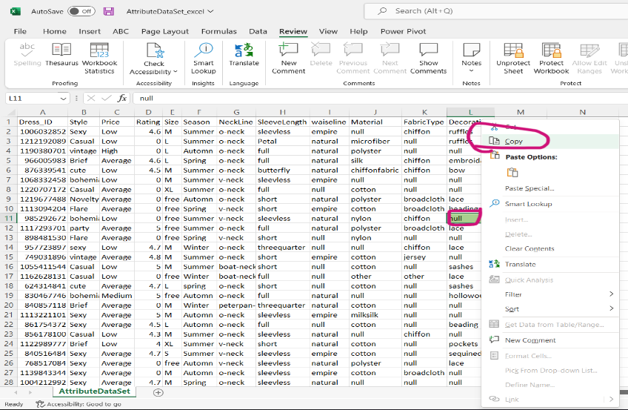

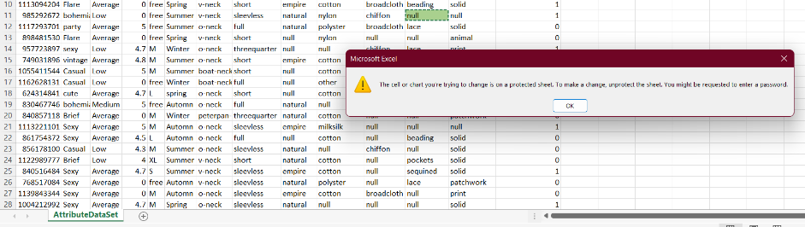

* To Remove worksheet protection, click the unprotect sheet buttion in the changes group on the Review tab. You’ll be prompted to type the password that you had set for protection.

3. How to move or copy the worksheet into another workbook?

To move the worksheet into another workbook simply drag and drop is working

To copy the worksheet into another the same process but holding the CTRL key during drag and drop

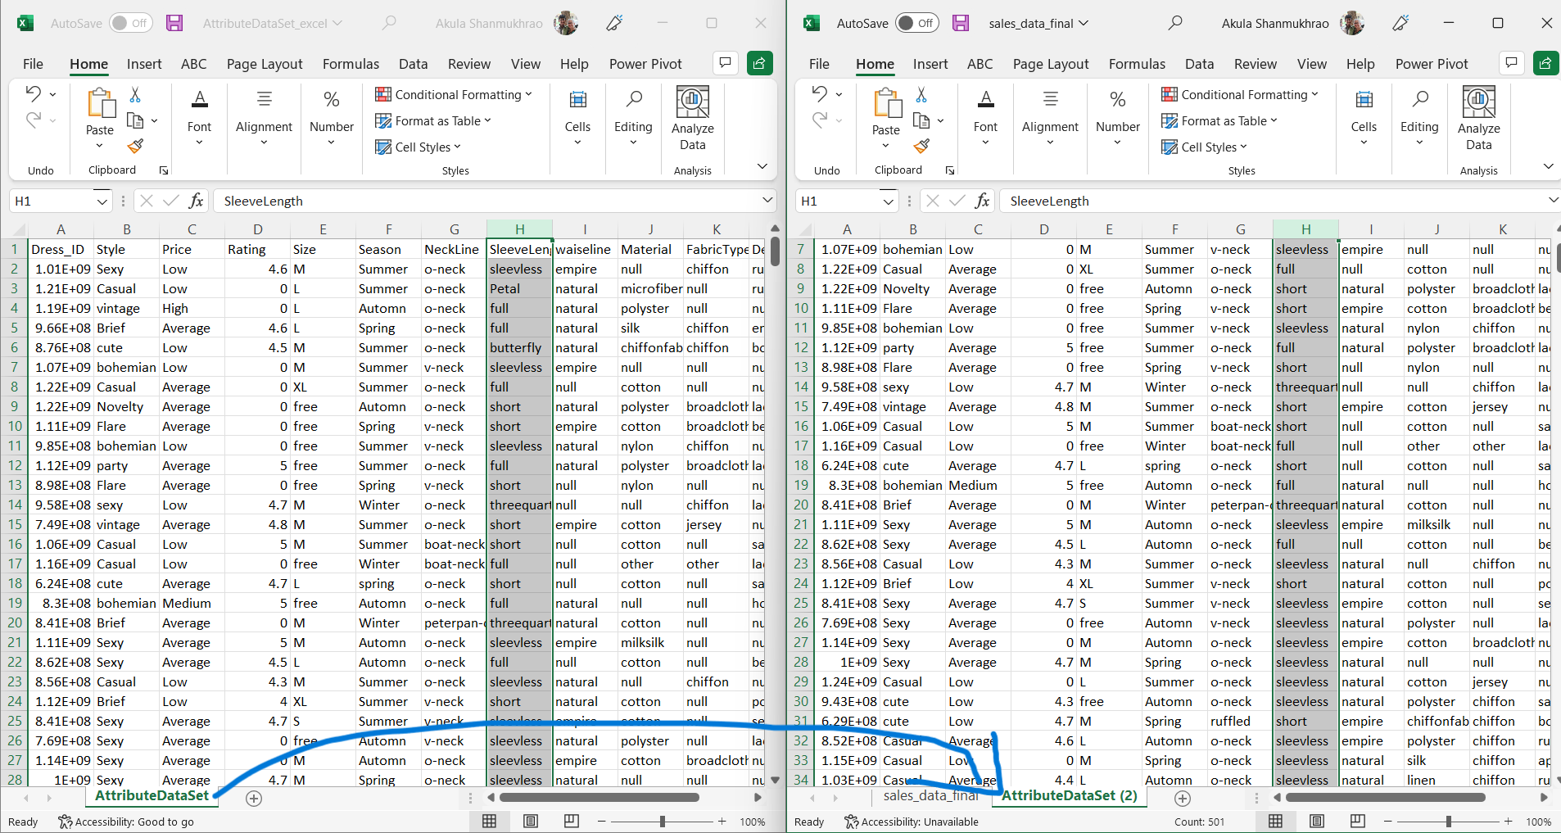

Another way is by right click the worksheet there one option as COPY OR MOVE. By selecting this option it displays the options to which workbook it is to be moved or copy and at which position (i.e. before some specific sheet or end). Also it gives an option for copy. To need copy select the copy check box.

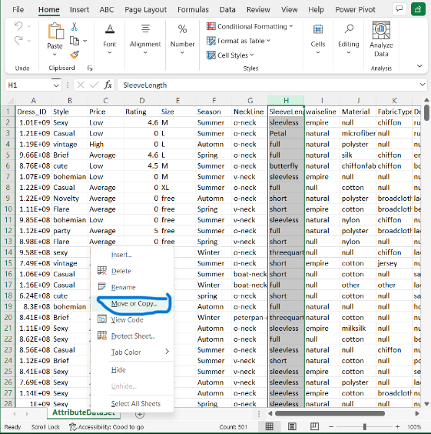 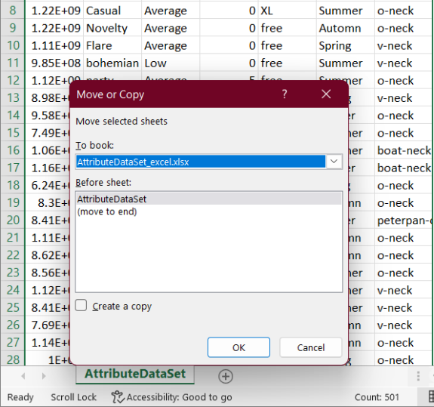

4. Which key is used as a shortcut for opening a new window document?

Ans : CTRL + O

5. What are the things that we can notice after opening the Excel interface?

Excel Interface

The Excel interface revolves around the ribbon, which is the strip of controls across the top section of the application window. The ribbon is comprised of tabs, which contain groups of controls, and this terminology is used to identify the location of tools. For example, bold font is applied to the selected range via the Home tab, Font group, Bold button.

The following image shows the Excel window with the Home tab active and an open workbook containing one empty worksheet:

6. When to use a relative cell reference in excel?

Relative cell references are basic cell references that adjust and change when copied or when using AutoFill.

Example:

=SUM(B5:B8), as shown below, changes to =SUM(C5:C8) when copied across to the next cell.

